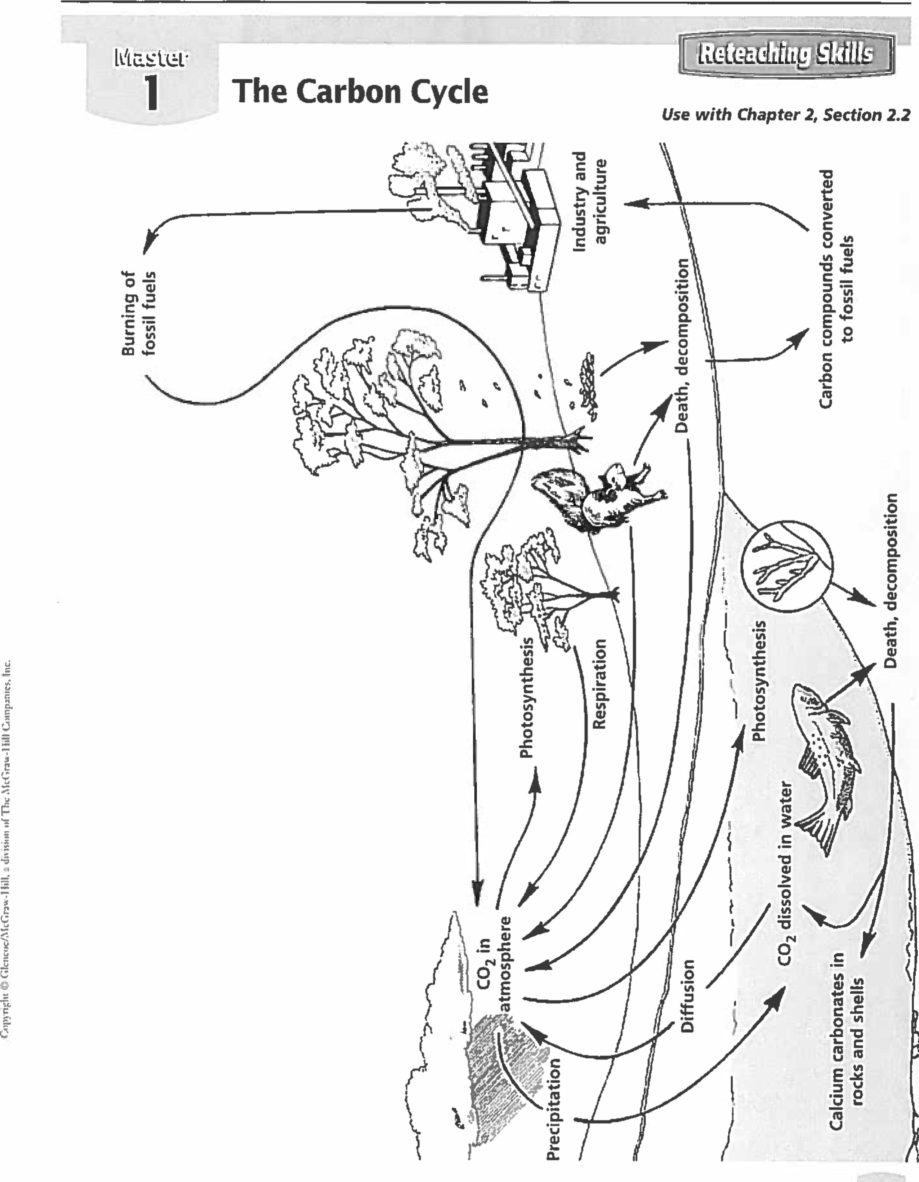

Natne

Date

Class

RETEACHING SKILLS TRANSPARENCY MASTER 1 BIOLOGY The Dynatnics of Life

1. What is the process by which plants convert carbon dioxide into energy-rich carbon compounds?

|  |
| --- |
|  |

1. Explain what can happen over millions of years to the carbon compounds in organisms that die and decompose.

|  |
| --- |
|  |

1. What processes in the transparency release carbon dioxide into the atmosphere?

|  |
| --- |
|  |

1. Identify the two major reservoirs of carbon dioxide on Earth.

|  |
| --- |
|  |

1. What are the forms in which carbon is found in the oceans?

|  |
| --- |
|  |

1. How do plants and animals help to maintain a balance of carbon dioxide in the atmosphere?

|  |
| --- |
|  |

1. Atmospheric carbon dioxide produces a so-called “greenhouse effect” by trapping heat near Earth’s surface. What human activities might tend to increase the greenhouse effect?

|  |
| --- |
|  |

1. In your own words, describe in detail the way carbon cycles through the biosphere. Start with the Carbon dioxide in the atmosphere. There should be 10 unique locations that carbon goes through. End the cycle back in the atmosphere.

|  |
| --- |
|  |